**Title: Single Agentic Systems VS Multi Agentic Systems**

**INDEX**

| **Sl. No.** | **Topic** | **Page No.** |
| --- | --- | --- |
| **1** | **Introduction to Agentic AI** | **1** |
| **2** | **Types and Classifications of Agents** | **4** |
| **3** | **Understanding Single-Agent Systems** | **7** |
| **4** | **Single-Agent Architectures, Learning Models & Decision Strategies** | **9** |
| **5** | **Advantages, Challenges & Use Cases of Single-Agent Systems** | **11** |
| **6** | **Understanding Multi-Agent Systems** | **13** |
| **7** | **Multi-Agent Architectures, Coordination, & Communication Mechanisms** | **15** |
| **8** | **Advantages, Limitations & Use Cases of Multi-Agent Systems** | **18** |
| **9** | **Single-Agent AI vs Multi-Agent AI** | **20** |
| **10** | **Real-world Applications** | **22** |
| **11** | **Societal, Ethical, and Technical Impacts** | **25** |

**1.Introduction to Agentic AI**

Agentic Artificial Intelligence (Agentic AI) refers to a class of intelligent systems designed to operate autonomously in pursuit of specific objectives by perceiving their environment, reasoning about it, and executing appropriate actions. Unlike traditional AI models that are typically trained for static, single-purpose tasks, Agentic AI systems possess the capability to adapt dynamically to evolving environmental conditions. These systems are also capable of interacting with other agents or humans, thereby facilitating complex cooperative or competitive behaviors.

The emergence of Agentic AI signifies a shift from traditional data-driven models toward **goal-oriented intelligence**, where agents are not only reactive to inputs but also proactive in achieving defined missions. These systems combine techniques from artificial intelligence, cognitive science, control theory, and behavioral modeling to enable more flexible and human-like decision-making. Agentic AI, therefore, represents a critical advancement in the pursuit of machines that can think, reason, and act with purpose.

#### **Key Characteristics of Agentic AI**

1. Autonomy:  
    Agentic AI operates with minimal or no human intervention, making decisions independently based on its perception and internal goals.
2. Reactivity:  
    Such systems continuously monitor their environment and respond to changes in real time to maintain or enhance performance.
3. Proactiveness:  
    Beyond mere reaction, Agentic AI anticipates potential future scenarios and takes pre-emptive actions to achieve long-term objectives.
4. Social Ability:  
    These agents can communicate, coordinate, and negotiate with other agents or human users to accomplish shared or conflicting goals effectively.

#### **Significance of Agentic AI**

Agentic AI represents a convergence of artificial intelligence, control theory, and behavioral modeling, forming the foundation for next-generation intelligent ecosystems. These include applications such as autonomous vehicles, robotic swarms, smart grids, intelligent healthcare systems, and collaborative industrial automation. By enabling adaptive and cooperative decision-making, Agentic AI promotes systems that are not only intelligent but also contextually aware and resilient.

**Single-Agent and Multi-Agent Systems**

Within the domain of Agentic AI, two primary paradigms are recognized — Single-Agent Systems and Multi-Agent Systems (MAS).

1. Single-Agent Systems:  
    A single-agent system comprises one autonomous agent that operates independently within its environment. Its primary objective is to optimize its performance based on defined goals, without the need to coordinate or interact with other agents. Examples include an autonomous vacuum cleaner navigating a room, or a self-driving car operating in an isolated test environment. In such systems, the complexity lies primarily in the interaction between the agent and its environment rather than in agent-to-agent communication.
2. Multi-Agent Systems:  
    In contrast, multi-agent systems consist of multiple autonomous agents that coexist and interact within a shared environment. Each agent may have distinct goals, perceptions, and decision-making strategies. These agents collaborate or compete to achieve individual or collective objectives. Multi-agent systems are characterized by the dynamics of coordination, negotiation, communication, and distributed problem-solving. Examples include autonomous drone fleets, smart energy grids, and robotic teams performing cooperative tasks. The emergent behavior of a multi-agent system often exceeds the capabilities of individual agents, resulting in more robust and scalable intelligence.

The agentic workflow follows a continuous feedback loop of sensing, reasoning, acting, and learning.

### **Workflow Steps**

1. Sense: Collect environmental data using sensors, APIs, or data feeds.
2. Interpret: Transform raw inputs into meaningful state representations.
3. Decide: Choose actions using algorithms like planning, optimization, or reinforcement learning.
4. Act: Execute the chosen action to influence the environment.
5. Evaluate: Assess results using reward functions or metrics.
6. Learn: Adjust future behavior through feedback.

**To explain this in better way we can refer to the visualization below :**

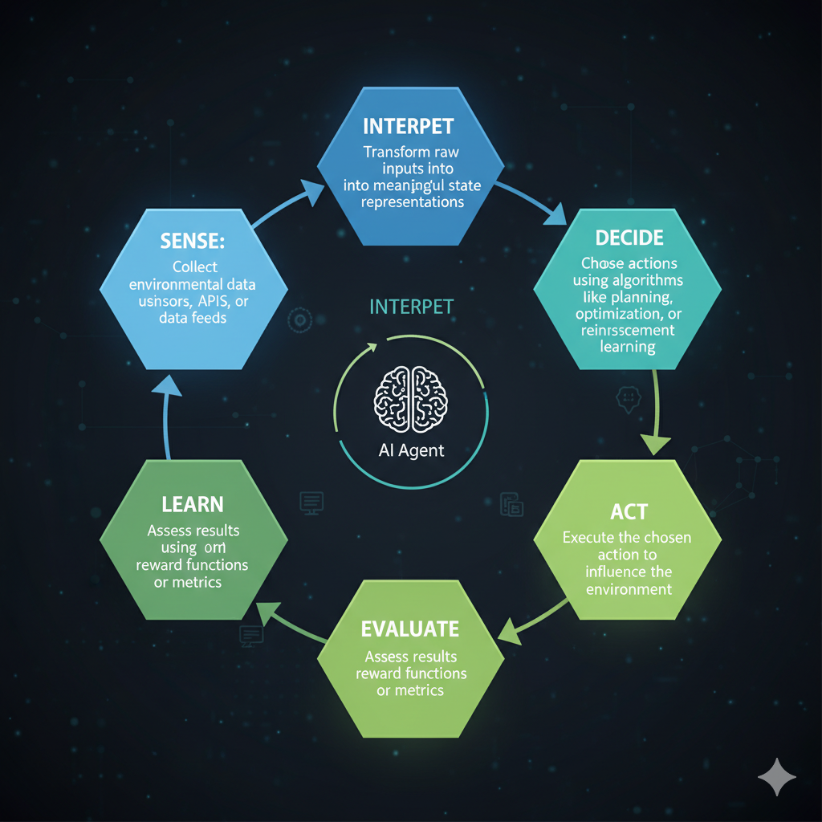

**2.Types and Classifications of Agents**

Agents in Agentic Artificial Intelligence (AI) are broadly categorized based on their internal architecture, reasoning mechanisms, and decision-making approaches. This classification helps in understanding how different agents perceive their environments, process information, and take action to achieve specific goals. The four primary categories are Reactive Agents, Deliberative Agents, Hybrid Agents, and Learning Agents. Each type exhibits distinct operational characteristics and can exist within both single-agent and multi-agent frameworks, depending on whether it functions independently or collaboratively.

#### **1. Reactive Agents**

Reactive agents function on a direct stimulus–response mechanism, governed by predefined condition–action rules (commonly expressed as if–then logic). They do not possess internal representations or memories of past states; instead, they respond immediately to environmental stimuli.  
 For example, a thermostat that detects temperature changes and adjusts heating or cooling accordingly exemplifies reactive behavior. Such agents are highly efficient in dynamic yet predictable environments where quick responses are critical. However, their lack of reasoning and planning capabilities limits their performance in complex or uncertain scenarios. Reactive agents are typically employed in systems where speed and simplicity take precedence over long-term strategy.

#### **2. Deliberative Agents**

Deliberative agents employ a more sophisticated form of intelligence. They construct and maintain an internal model of the environment, allowing them to reason about the current state, predict future outcomes, and plan sequences of actions to achieve their objectives.  
 Unlike reactive agents, deliberative agents rely on goal-directed reasoning, which involves evaluating multiple possible actions before making a decision.

Examples include autonomous robots that map their surroundings to plan efficient navigation paths or strategic game agents that simulate potential moves before acting. These agents are better suited for complex and dynamic environments where planning, adaptation, and foresight are required, although their computational demands are generally higher.

#### **3. Hybrid Agents**

Hybrid agents combine the advantages of both reactive and deliberative architectures to balance immediacy with intelligence. Their design typically incorporates a two-layered structure: a reactive layer that manages real-time responses and a deliberative layer that handles higher-level reasoning and goal planning.  
For instance, an autonomous vehicle must instantly react to sudden obstacles (reactive behavior) while also maintaining a planned route and optimizing travel time (deliberative behavior). This integration allows hybrid agents to operate effectively in uncertain and dynamic environments, making them ideal for real-world applications where both rapid responsiveness and strategic planning are necessary. Hybrid agents are also commonly used in multi-agent systems, where coordination and adaptability are crucial.

#### 

#### **4. Learning Agents**

Learning agents represent the most advanced class of agents in Agentic AI. They possess the ability to improve their performance over time through experience, observation, and feedback from the environment. These agents employ various machine learning techniques, including reinforcement learning, supervised learning, or unsupervised learning, to refine their behavior and optimize decision-making.  
For example, a reinforcement learning agent may interact with an environment, receive rewards or penalties, and adjust its strategy to maximize long-term rewards. This adaptability enables learning agents to function effectively in uncertain, evolving, or data-rich environments, making them particularly valuable in areas such as finance, robotics, personalized recommendations, and adaptive control systems.

**3. Understanding Single-Agent Systems**

A **Single-Agent System (SAS)** is an intelligent entity that perceives its environment, makes decisions, and performs actions autonomously to achieve specific goals. In this type of system, there is only **one decision-making unit**, which means the agent operates independently without the presence or interference of other agents. Its entire focus is on understanding the environment, evaluating possible actions, and selecting the one that best fulfills its objectives.

The agent continuously follows a **sense–think–act** cycle:

1. **Sensing:** It gathers information from its surroundings through sensors or data inputs.
2. **Thinking (Reasoning):** It analyzes this information, predicts possible outcomes, and formulates a strategy or plan.
3. **Acting:** It executes actions that alter the environment to move closer to its goal.

Formally, a single-agent system can be represented as a tuple:

SAS=(S,A,T,R)SAS = (S, A, T, R)SAS=(S,A,T,R)

where:

* **S (States):** All possible configurations of the environment.
* **A (Actions):** The set of actions the agent can perform.
* **T (Transition Model):** Describes how actions change the environment.
* **R (Reward Function):** Defines the utility or desirability of outcomes.

This structure forms the foundation of **Markov Decision Processes (MDPs)**, where the agent aims to maximize cumulative rewards through optimal decision-making.

The operational flow of a SAS follows the **Perception–Reasoning–Action** cycle: the agent senses its environment, interprets observations, decides the best course of action, and acts—receiving feedback to refine future behavior.

**Example:** A **self-driving delivery robot** in a warehouse observes shelves, plans routes, avoids obstacles, and completes deliveries autonomously. It exemplifies the characteristics of a single-agent system—autonomy, adaptability, and goal-oriented decision-making.

**4. Single-Agent Architectures, Learning Models & Decision Strategies**

**Architectural Models:** Single-agent systems can follow different architectural approaches depending on their design and complexity.

**Rule-Based:** Operate on predefined *if–then* rules, suitable for simple tasks but limited in adaptability.

**Model-Based:** Maintain an internal model of the environment, allowing better reasoning about unseen states.

**Goal-Based:** Focus on achieving specific objectives, selecting actions that lead closer to desired outcomes.

**Utility-Based:** Evaluate and choose actions that maximize overall performance or utility, balancing multiple goals.

**Learning Mechanisms:** Single agents enhance their performance using various learning methods:

* **Supervised Learning:** Builds predictive models from labeled data.
* **Reinforcement Learning (RL):** Learns optimal actions through trial, feedback, and rewards.
* **Neural-Symbolic Reasoning:** Integrates deep learning’s pattern recognition with symbolic reasoning for better decision-making.

**Decision-Making Strategies:** Agents employ algorithms such as **A\*** search, **Markov Decision Processes (MDPs)**, or **Deep Q-Learning** to evaluate possible actions and select the most efficient path toward their goals.

**Workflow Example – Autonomous Drone Agent:**

1. **Sense:** Captures environmental data using cameras and GPS.
2. **Plan:** Computes the safest and most efficient flight route while avoiding obstacles.
3. **Act:** Adjusts flight path and executes planned movements.
4. **Learn:** Updates its navigation model based on feedback and performance for future improvements.

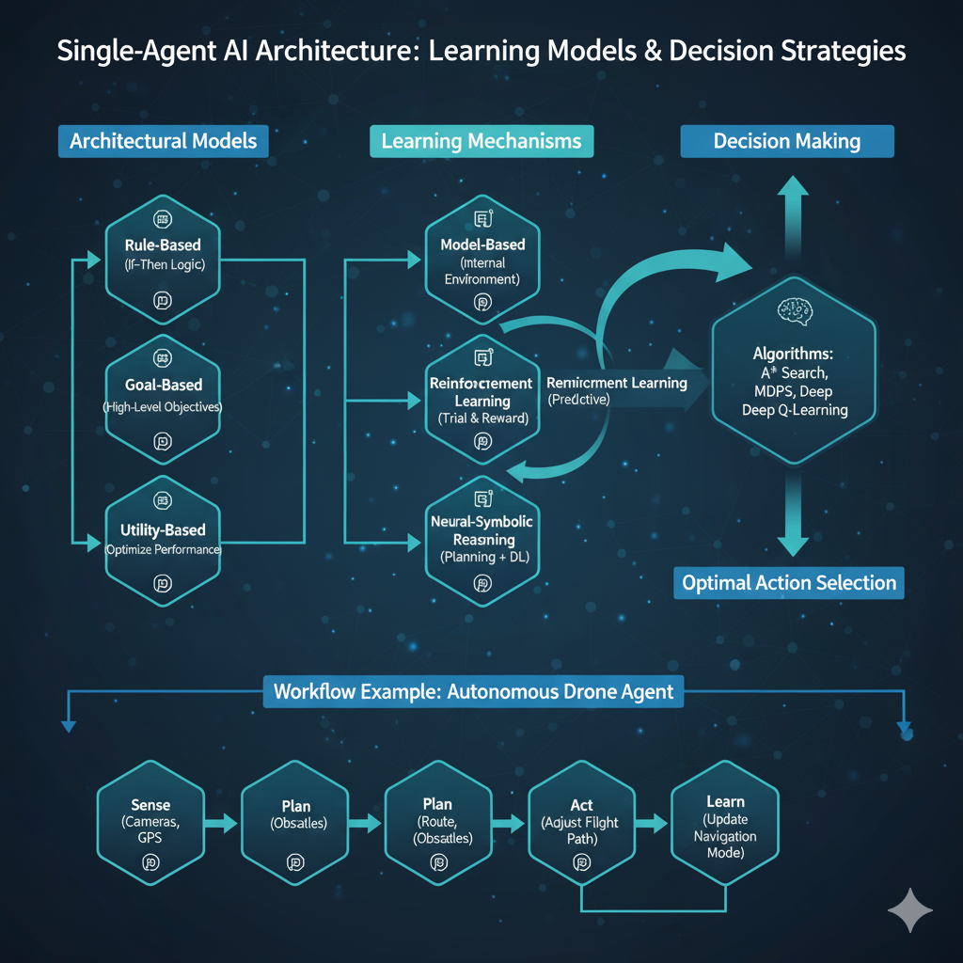

**5. Advantages, Challenges & Use Cases of Single-Agent Systems**

**Advantages:**

* **Predictable behavior:** Single-agent systems act consistently, making their actions easier to understand and anticipate.
* **Simple communication:** Since only one agent operates, there’s no need for complex coordination or message exchange.
* **Task efficiency:** Ideal for focused, individual tasks where collaboration isn’t required.
* **Ease of testing and deployment:** Simpler architecture allows faster development, debugging, and real-world deployment.

**Challenges:**

* **Limited scalability:** They struggle with large-scale or distributed problems that require multiple cooperating entities.
* **Single point of failure:** If the agent malfunctions, the entire system can fail due to lack of redundancy.
* **Lack of coordination:** They cannot collaborate, compete, or negotiate with other agents to achieve shared goals.

**Use Cases:**

* **Personal voice assistants:** Systems like Siri or Alexa that perform tasks for individual users.
* **Autonomous drones or robots:** Single units performing navigation or delivery tasks independently.
* **Fraud detection bots:** AI tools monitoring transactions to detect suspicious activities in banking systems.
* **AI diagnostic assistants:** Healthcare applications that analyze symptoms and suggest potential conditions autonomously.

### **6. Understanding Multi-Agent Systems**

A **Multi-Agent System (MAS)** is a computational system composed of multiple autonomous entities, known as *agents*, that interact within a shared environment to achieve individual or collective goals. Each agent possesses its own perception, reasoning, and decision-making capabilities, allowing it to act independently while also coordinating or competing with others. The agents may have either aligned or conflicting objectives, and their interactions give rise to complex system behaviors that are often greater than the sum of their individual actions.

Unlike single-agent systems, which focus on the intelligence of one centralized entity, a multi-agent system distributes intelligence across several agents. This distribution enhances scalability, flexibility, and problem-solving efficiency, especially in dynamic or decentralized environments. MAS is particularly effective in domains where cooperation, negotiation, and resource sharing are essential.

The **key concept** behind multi-agent systems is *emergent intelligence* — the system’s overall intelligence emerges from the collective interactions, cooperation, and competition among agents, rather than being explicitly programmed. This enables MAS to handle complex, large-scale problems such as traffic management, distributed robotics, and supply chain coordination.

**Example:** A swarm of autonomous delivery drones collaboratively dividing and managing delivery routes to minimize time and energy consumption, or a group of intelligent robots working together on an assembly line, each responsible for specific tasks yet synchronized through communication and shared goals.

**Core Elements of Multi-Agent Systems:**

* **Autonomous Agents:** Each agent operates independently, perceives its surroundings, and makes local decisions to achieve its objectives.
* **Shared Environment:** All agents coexist and act within a common environment, which may be physical (e.g., factory floor) or virtual (e.g., online trading systems).
* **Interaction Protocols:** Rules and structures that govern communication, negotiation, and coordination among agents — including message exchange, auctions, or consensus algorithms.
* **Coordination Mechanisms:** Frameworks enabling cooperation, competition, or hybrid interactions to ensure agents work efficiently toward individual or collective goals

### **7. Multi-Agent Architectures, Coordination, & Communication Mechanisms**

In a **Multi-Agent System (MAS)**, the overall efficiency and intelligence depend on how agents are structured, how they coordinate actions, and how they communicate with one another. The system architecture defines the organization of agents, while communication and coordination mechanisms determine how information is shared and collective decisions are made.

#### **Architectural Models**

1. **Centralized MAS:** In this structure, a single leader or central controller oversees all agents, managing task allocation and decision-making. While this approach ensures global coordination and simplified control, it can create bottlenecks and a single point of failure. Example: A central traffic management system controlling all autonomous vehicles in a network.
2. **Decentralized MAS:** Here, each agent operates autonomously, making local decisions while sharing only essential information with others. This model enhances scalability, robustness, and adaptability, making it suitable for large-scale or distributed environments such as swarm robotics or distributed sensor networks.
3. **Hierarchical MAS:** This hybrid model combines the advantages of centralized and decentralized systems. Agents are organized in layers—higher-level agents handle strategy and coordination, while lower-level agents execute tasks. It balances control and flexibility, commonly seen in smart manufacturing or energy grid systems.

#### **Communication Mechanisms**

1. **Direct Messaging:** Agents communicate through explicit message exchanges, sharing data, requests, or status updates in real time. This method supports precise coordination but may become communication-heavy in large systems.
2. **Blackboard Systems:** All agents read from and write to a shared data repository or “blackboard.” This facilitates collaboration without direct communication, often used in problem-solving or knowledge-sharing environments.
3. **Market-Based Systems:** Inspired by economic principles, agents negotiate, bid, or trade resources to reach optimal allocation or decisions. This approach encourages self-organization and is commonly used in logistics and resource distribution tasks.
4. **Emergent Coordination (Stigmergy):** Agents coordinate indirectly through environmental changes — for instance, digital pheromone trails in swarm robotics. This mechanism promotes scalable, self-organizing behavior without explicit communication.

#### **Workflow Example: Smart Grid Multi-Agent System**

* **Sense:** Each agent monitors local power demand, supply, and consumption data.
* **Communicate:** Agents share information with neighboring grid nodes.
* **Negotiate:** Agents collaborate to balance load and optimize pricing dynamically.
* **Act:** The system autonomously adjusts power distribution to maintain grid stability and efficiency.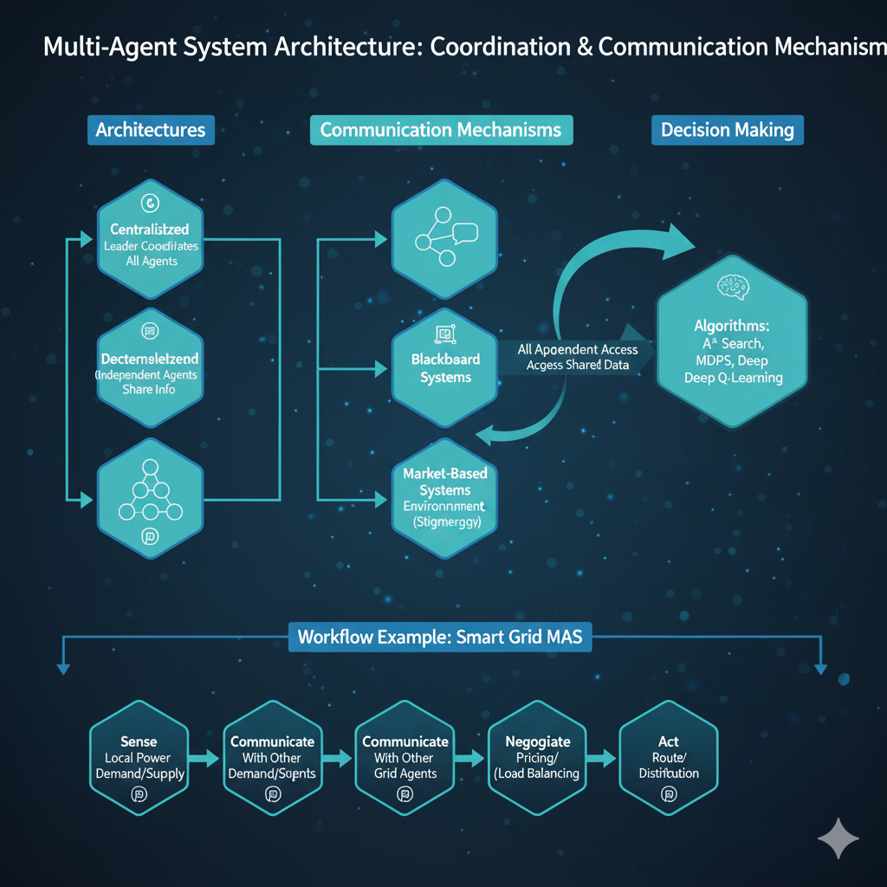

.

**8. Advantages, Limitations & Use Cases of Multi-Agent Systems**

**Advantages:**

* **Scalability and Modularity:** Multi-agent systems can easily expand by adding more agents without redesigning the entire system.
* **Robustness through Redundancy:** If one agent fails, others can compensate, ensuring system stability and reliability.
* **Efficiency in Dynamic Environments:** Agents adapt quickly to environmental changes, maintaining optimal performance in real time.
* **Effective Distributed Control:** MAS enables decentralized decision-making, making it ideal for complex, large-scale systems.

**Limitations:**

* **Coordination Complexity:** Managing inter-agent cooperation and synchronization can become challenging as the system grows.
* **Communication Overhead:** Continuous information exchange among agents may lead to increased network load and latency.
* **Conflict Management:** Agents pursuing different goals can create conflicts that require negotiation or resolution mechanisms.

**Use Cases:**

* **Smart Traffic Management:** Coordinated traffic lights and vehicles improve flow and reduce congestion.
* **Collaborative Industrial Robots:** Multiple robots work together on manufacturing or assembly tasks efficiently.
* **Distributed Cybersecurity Monitoring:** Agents detect, analyze, and respond to network threats in real time.
* **Intelligent Tutoring Systems:** Multiple educational agents adapt learning experiences based on student behavior and performance.

**9. Single Agent AI Vs Multi Agent AI**

| **Aspect** | **Single-Agent System** | **Multi-Agent System** |
| --- | --- | --- |
| **Definition** | One autonomous entity that perceives and acts to achieve goals. | Multiple interacting agents that cooperate or compete to achieve goals. |
| **Complexity** | Simpler to design and control. | More complex due to coordination and communication. |
| **Communication** | Not required — only one agent. | Essential for coordination and task sharing. |
| **Decision Making** | Centralized — one agent makes all decisions. | Decentralized — each agent makes local decisions. |
| **Failure Impact** | System stops if the agent fails. | Resilient — others can continue functioning. |
| **Examples** | Chatbots, personal assistants, self-driving cars. | Smart traffic systems, robotic swarms, supply chain networks. |

**10. Real-world Applications**

**Healthcare**

* **Single-Agent System (SAS):** A diagnostic AI model independently analyzes patient scans such as X-rays or MRIs to detect diseases like pneumonia or tumors without external coordination.
* **Multi-Agent System (MAS):** Multiple intelligent agents manage hospital operations collaboratively — one handles patient data, another schedules doctors, while others coordinate medical equipment and resource allocation, ensuring smooth hospital logistics.

**Mobility**

* **SAS:** An autonomous vehicle equipped with sensors and control algorithms performs lane-keeping, obstacle avoidance, and speed control individually.
* **MAS:** A network of connected vehicles communicates with each other and with traffic infrastructure to optimize routes, prevent congestion, and ensure city-wide traffic coordination.

**Customer Service**

* **SAS:** A standalone chatbot interacts with users, answering queries or resolving basic issues based on pre-trained language models.
* **MAS:** A collection of specialized AI modules — including natural language processing, query routing, and context memory — collaborate to deliver seamless, context-aware customer support.

**Finance**

* **SAS:** Individual trading bots analyze market trends and execute buy or sell orders based on predefined strategies for specific assets.
* **MAS:** Multiple financial agents simulate or manage market dynamics collectively, interacting and competing to predict trends, balance portfolios, or detect fraud in real time.

**Robotics**

* **SAS:** A single robotic arm performs a specific, repetitive task such as assembling components or packaging goods on a production line.
* **MAS:** Swarm robotics enables large groups of autonomous robots to collaborate in warehouse automation, where they coordinate inventory movement, order fulfillment, and resource sharing efficiently.

#### **Education**

* **SAS:** An AI-based tutoring system independently provides personalized learning experiences, evaluating a student’s progress and adapting lesson difficulty.
* **MAS:** Collaborative educational platforms where multiple AI tutors and agents interact — one tracking progress, another recommending materials, and others providing feedback — to create a dynamic, adaptive learning environment.

#### **Smart Cities**

* **SAS:** A single AI system controls street lighting or waste management in one area using sensor-based automation.
* **MAS:** Interconnected agents manage various city systems like traffic, energy, water, and public safety in real time, sharing data to ensure efficient urban operations and sustainability.

**11. Societal, Ethical, and Technical Impacts**

The advancement of **Agentic AI**, encompassing both single-agent and multi-agent systems, has brought profound transformations across industries and society. These systems enhance operational efficiency and decision-making but also introduce new ethical and technical challenges that demand responsible design and governance.

#### **Positive Impacts**

* **Reduced Human Workload:** Automation of repetitive, data-intensive, or hazardous tasks minimizes manual effort, allowing humans to focus on strategic or creative work.
* **Higher Efficiency and Safety:** Intelligent systems can operate continuously with precision, reducing errors in critical domains such as healthcare, transportation, and manufacturing.
* **Improved Decision-Making:** Distributed intelligence across agents facilitates data-driven, real-time decisions that enhance system adaptability and overall performance.

#### **Risks**

* **Bias Propagation:** If trained on biased data, agentic systems may unintentionally reinforce social or algorithmic biases, leading to unfair or discriminatory outcomes.
* **Systemic Failures:** In complex multi-agent environments, a single malfunctioning agent or communication breakdown can trigger cascading failures across the system.
* **Lack of Explainability:** Many AI-driven decisions, especially those from deep learning or reinforcement learning models, remain opaque, making it difficult to justify or audit outcomes.

#### **Ethical Considerations**

* **Transparency in Decision-Making:** Systems should provide interpretable insights into how and why decisions are made to foster user trust and regulatory compliance.
* **Accountability for Autonomous Outcomes:** Clear responsibility frameworks must be established to determine who is liable when autonomous agents make independent decisions.
* **Human-in-the-Loop Design:** Incorporating human oversight in critical decision processes ensures ethical alignment, safety assurance, and prevention of unintended consequences.